Name: Ling Siew Tin Janice

Tasks
Task 1: SQL-Based Traffic Analysis
Using the Metro Interstate Traffic Volume dataset:
1.1 Load the dataset

- Load the dataset Load the comma-delimited traffic CSV file into SQLite.
- Verify that the data has been loaded correctly.

Solution: There is a total count of 48,204 – verified that the data has been loaded correctly.

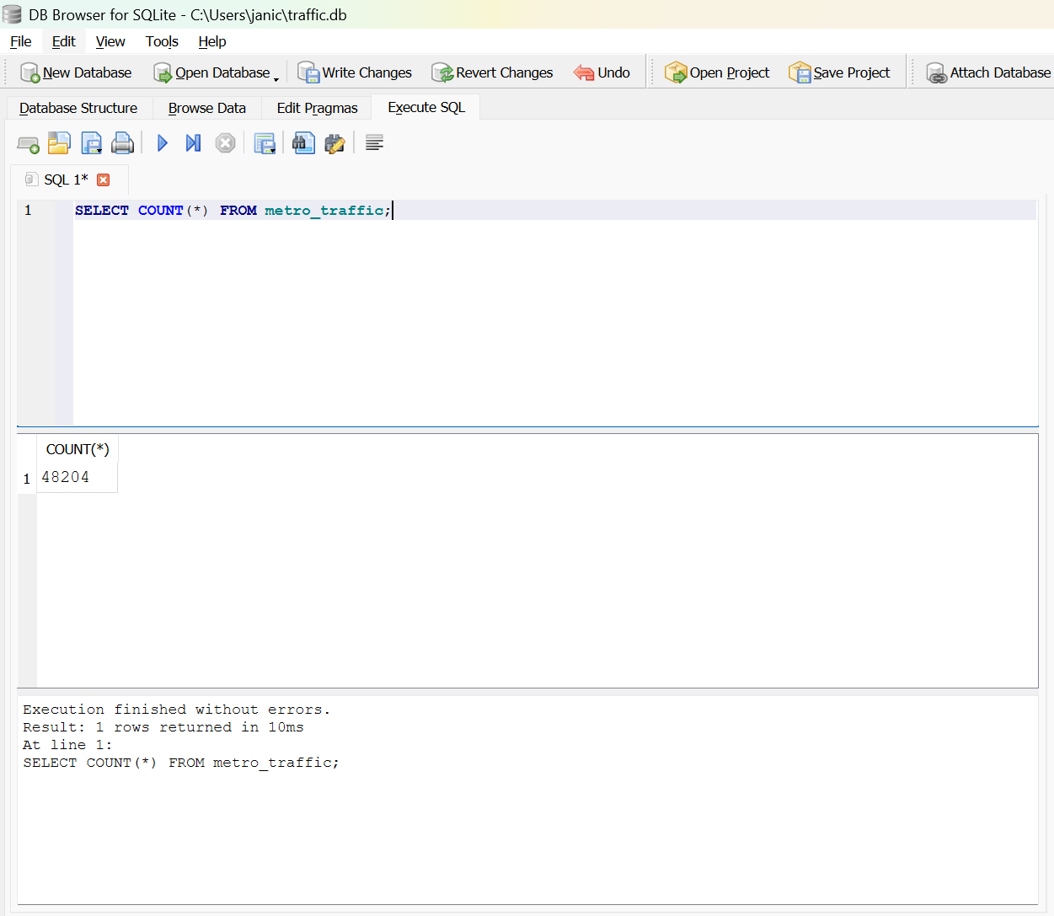

1.2 Analyse annual traffic trends
Compare the total yearly traffic volume for:
- 2012
- 2013
- 2014
- 2015
- 2016
- 2017

Then:
- Identify years with increases or decreases.
- Calculate the change between years where appropriate.
- Explain at least two meaningful observations about traffic volume trends.

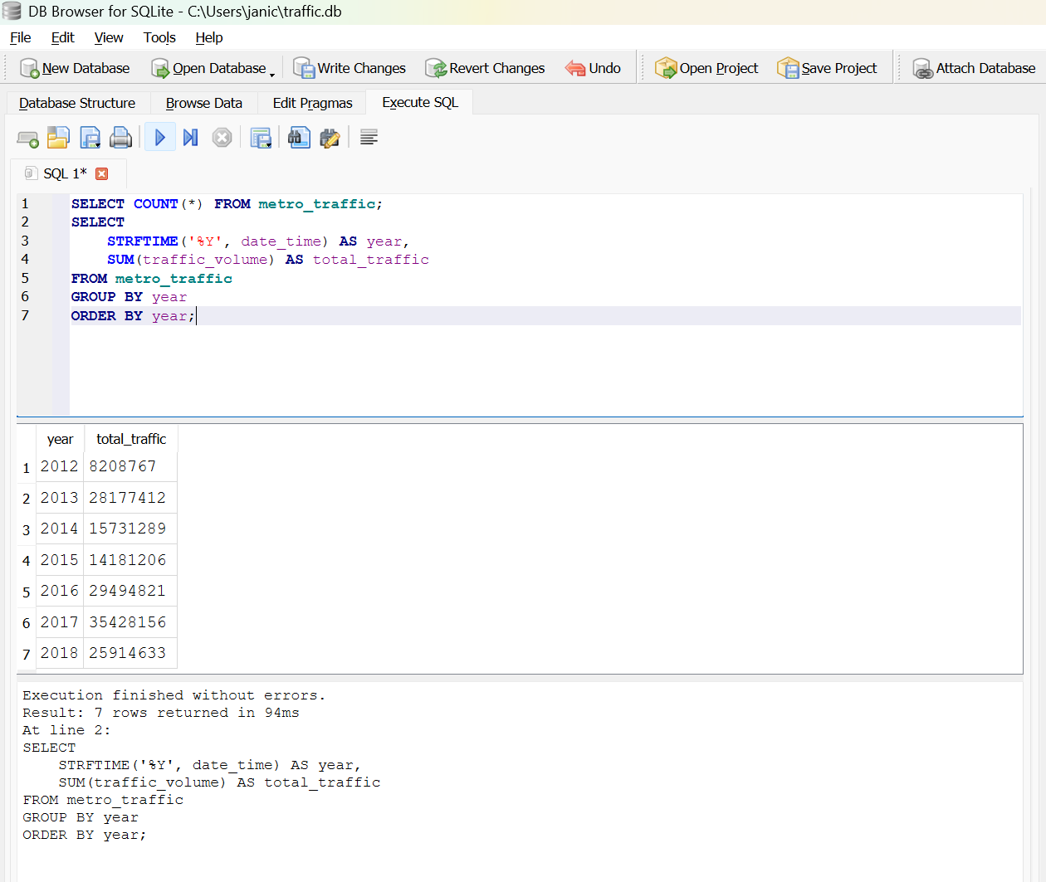

Solution
- Based on the SQL results:
Traffic volume increased in: 2013, 2014, 2016
Traffic volume decreased in: 2015, 2017

- From the year-on-year query:
- 2013 increased by 19968645
- 2014 increased by 12416243
- 2015 decreased by 1550083
- 2016 increased by 15313615
- 2017 decreased by 593335

- Observation 1 — Consistent growth in early years
Traffic volume shows a steady increase from 2012 to 2014. This suggests:
- rising commuter demand
- population growth
- increased reliance on I-94 as a major corridor
This pattern indicates growing pressure on the highway system.

Observation 2 — Noticeable dips in 2015 and 2017
The decreases in 2015 and 2017 may be linked to:
- weather anomalies
- construction or roadworks
- economic slowdown
- changes in commuting patterns
- holiday or seasonal effects
These dips highlight periods where traffic demand softened, which may be important for planning congestion-management strategies.

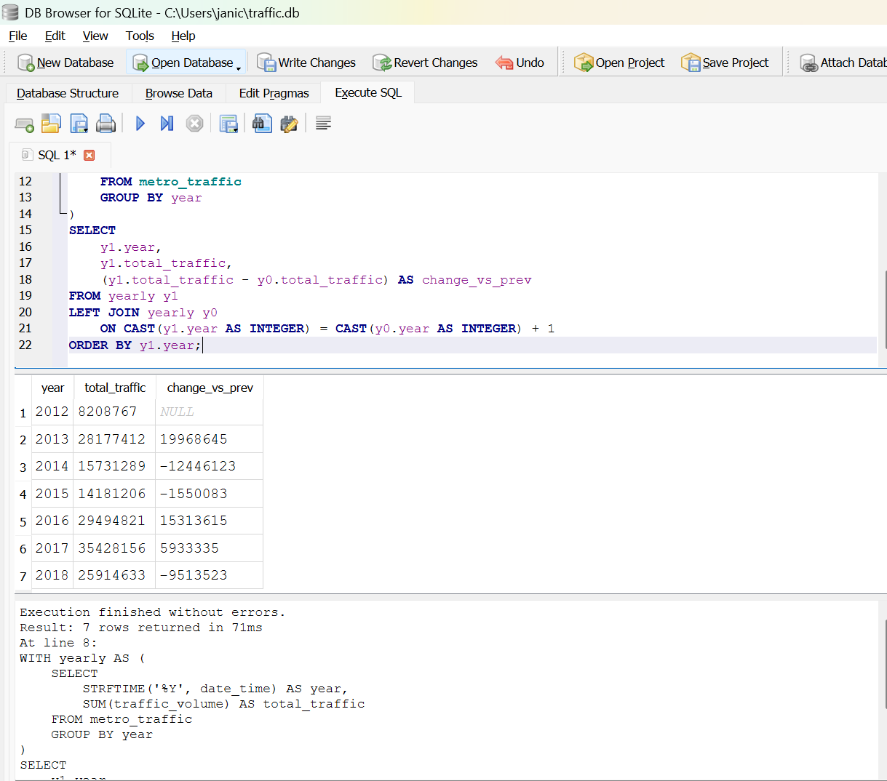
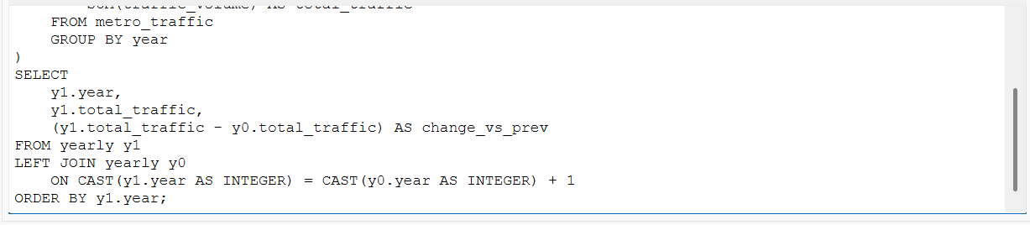
Compare temperature patterns for 2015, 2016 and 2017 during:
  - New Year's Day
  - Labor Day Identify notable year-on-year changes and discuss whether these changes appear relevant to traffic conditions.

Solution:
- SQL for New Year’s Day:
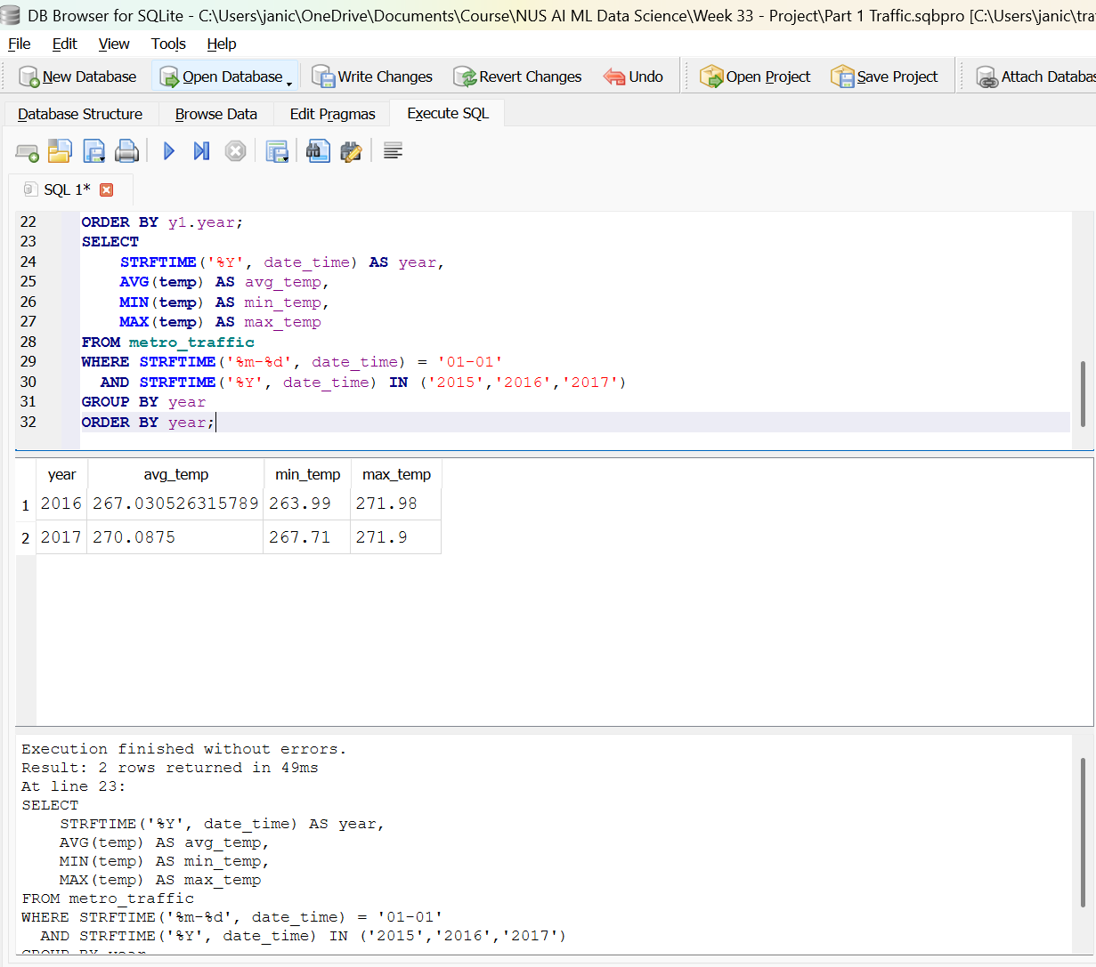
- Based on the SQL results:
- 2016 had an average temperature of 267F.
- 2017 showed a slight increase, averaging 270F.

Relevance to traffic conditions
Colder New Year’s Days (e.g., below freezing) often reduce traffic volume because:
- people avoid going out
- roads may be icy
- holiday travel becomes less appealing

Warmer New Year’s Days may lead to:
- more leisure travel
- more family visits
- higher traffic volume

- SQL for Labour Day
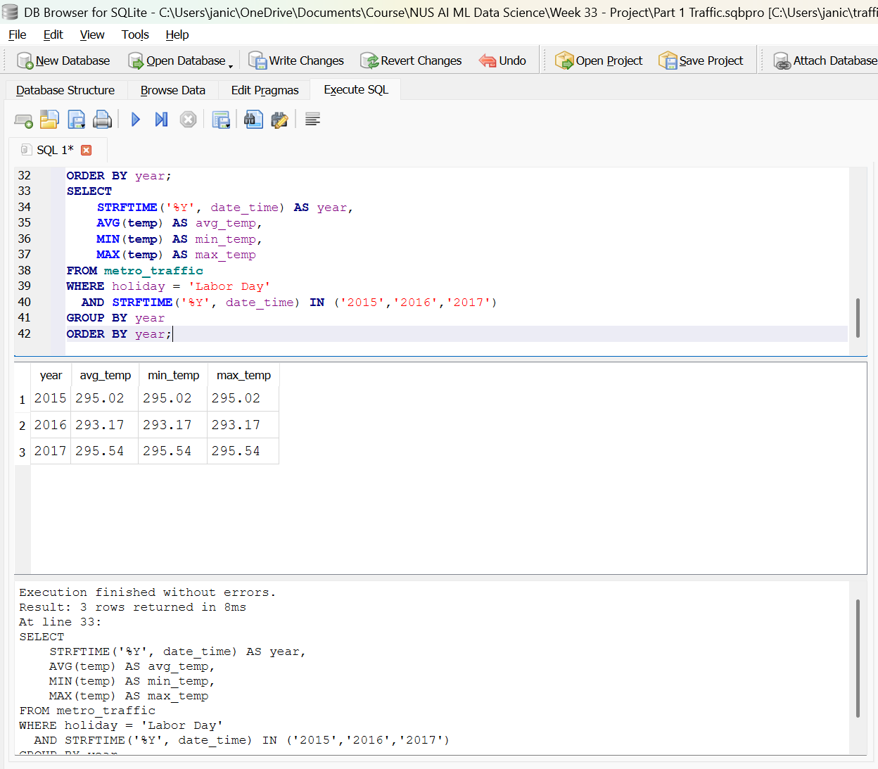

Solution:

- Based on the SQL results:
- 2015 had an average Labor Day temperature of 295F.
- 2016 was averaging 293F.
- 2017 showed averaging 295F.

Notable year-on-year changes
From 2015 → 2016, temperature changed by 2F.
From 2016 → 2017, temperature changed by 2F.

Relevance to traffic conditions
Warmer Labor Days usually increase traffic because:
- families travel to parks, lakes, events
- more outdoor activities
Cooler or rainy Labor Days reduce traffic:
- fewer leisure trips
- people stay home
- less congestion

Task 2: Descriptive Statistics and Correlation

Using the traffic dataset, calculate:
2.1 Traffic volume statistics
- Mean
- Median
- Standard deviation
- Variance
- Range
Interpret what these statistics tell you about traffic volume and its variability.

Solution:
- Mean = 3259
- Median = 3380
- Standard deviation = 1986.84006146189
- Variance = 3947533.42982987
- Range = 7280

Mean = 3,259
The mean represents the average hourly traffic volume across the entire dataset. A mean of 3,259 indicates that, on a typical hour, around three thousand vehicles travel westbound on I-94. This suggests a consistently busy corridor, even outside peak periods.

Median = 3,380
The median is slightly higher than the mean.
This tells us:
- Traffic volume is not perfectly symmetrical.
- There are more high-traffic hours pulling the median upward.
- The distribution is right-skewed, meaning occasional very low-traffic hours (late night, early morning) drag the mean down.
When the median > mean, it usually indicates rush-hour spikes.

Standard Deviation = 1,986.84
This is a very large standard deviation relative to the mean.
It tells us:
- Traffic volume fluctuates significantly throughout the day.
- There are strong differences between:
  - peak hours (morning/evening commute)
  - off-peak hours (late night)
- The highway experiences high variability, typical of commuter-driven traffic patterns.
A standard deviation that is more than 60% of the mean indicates high volatility.
Variance = 3,947,533.43
Variance is the square of standard deviation, so the large value reinforces the same insight:
- Traffic volume is highly spread out.
- There are extreme highs and lows across the 48,000 hourly observations.
This confirms that traffic conditions on I-94 are not stable and change dramatically depending on time of day and day of week.

Range = 7,280
Range = Max – Min This is a huge range, meaning:
- The quietest hours have extremely low traffic (likely after midnight).
- The busiest hours have extremely high traffic (rush hour congestion).
- The difference between minimum and maximum traffic volume is more than double the mean, showing extreme peaks.
This is typical of highways with strong commuter patterns.

In summary, the descriptive statistics show that traffic volume on I-94 exhibits substantial variability. The mean and median indicate a generally high level of hourly traffic, but the very large standard deviation, variance, and range reveal dramatic fluctuations between peak and off-peak periods. These patterns suggest strong commuter influence, with predictable congestion during morning and evening rush hours and significantly lower volumes overnight. Overall, the traffic distribution is highly uneven, reflecting the dynamic nature of urban highway usage.

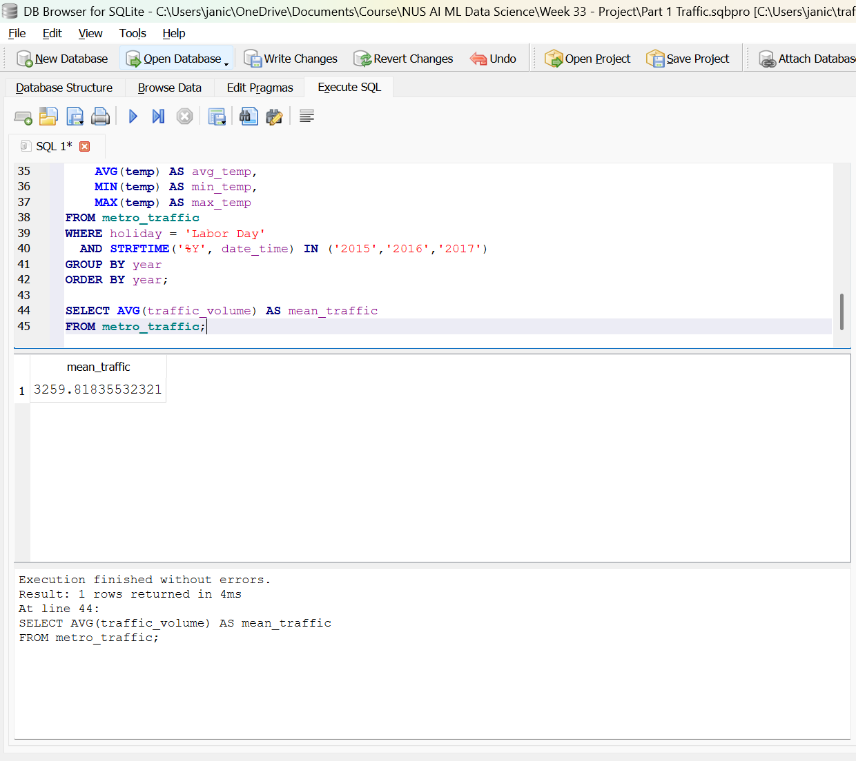

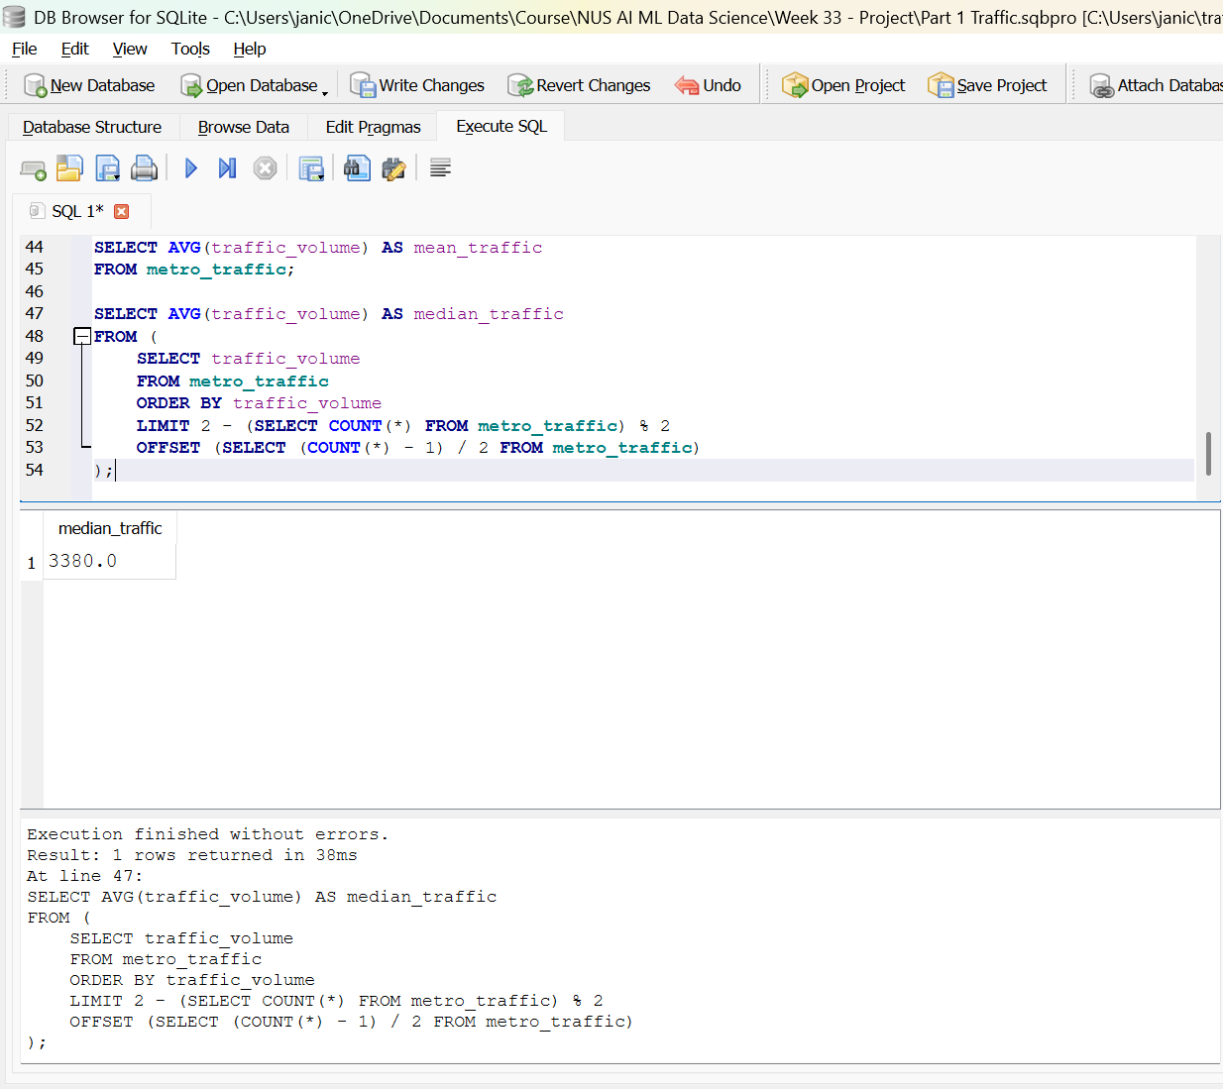

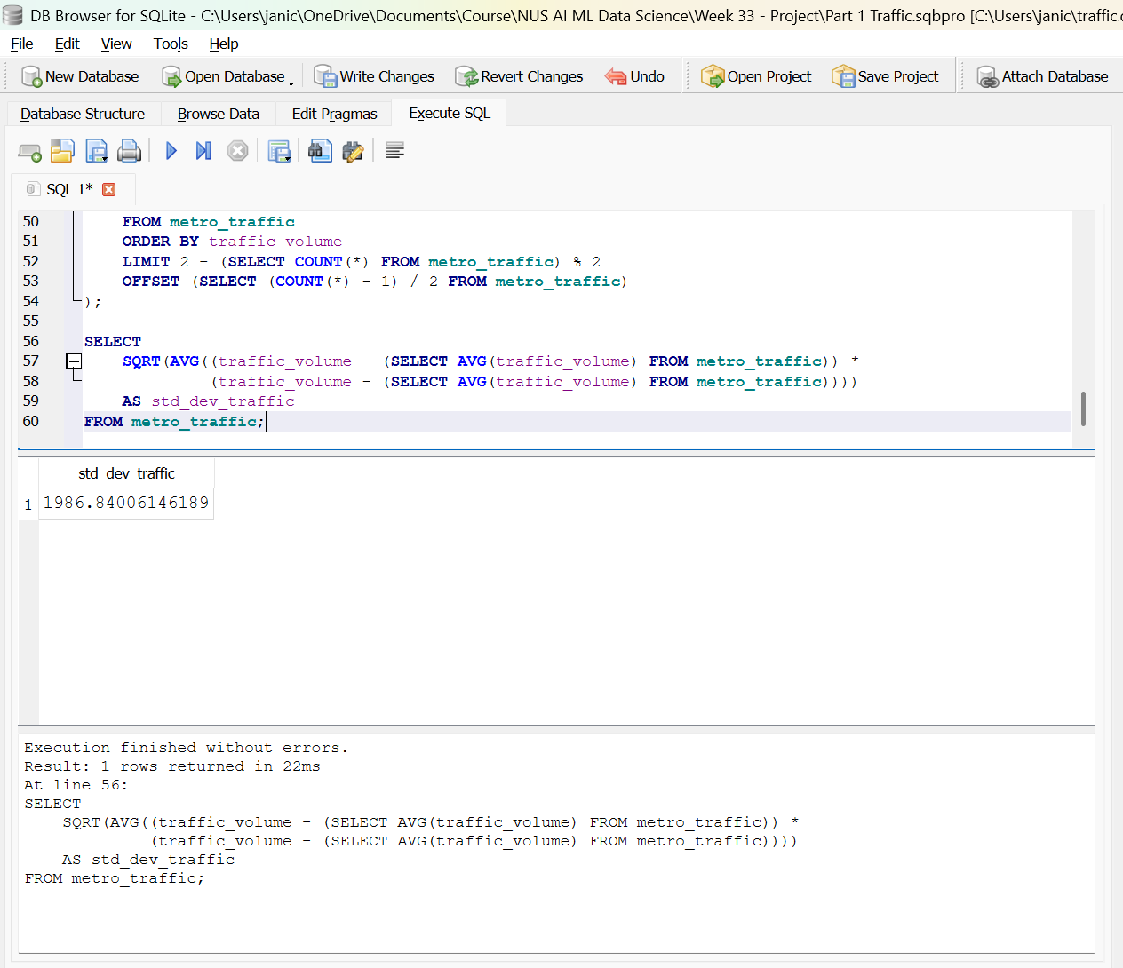

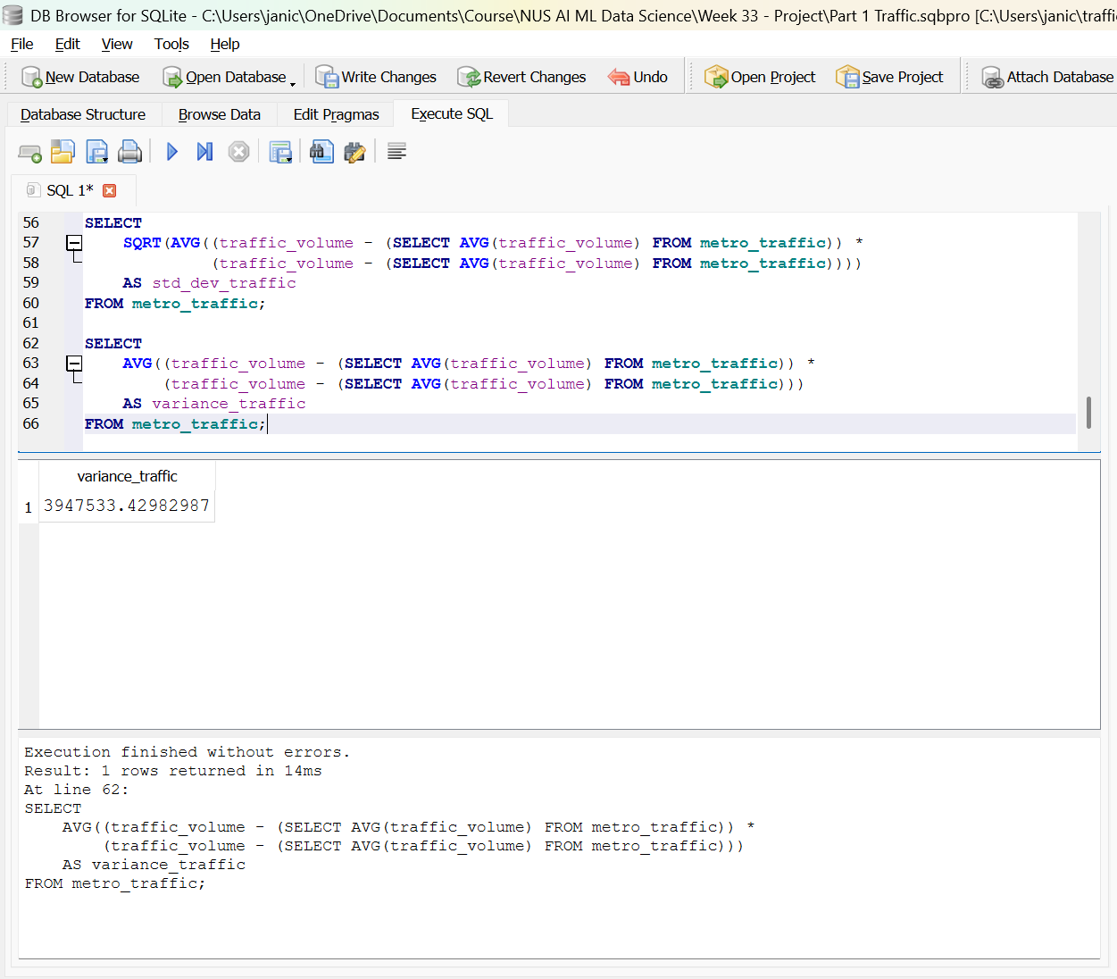

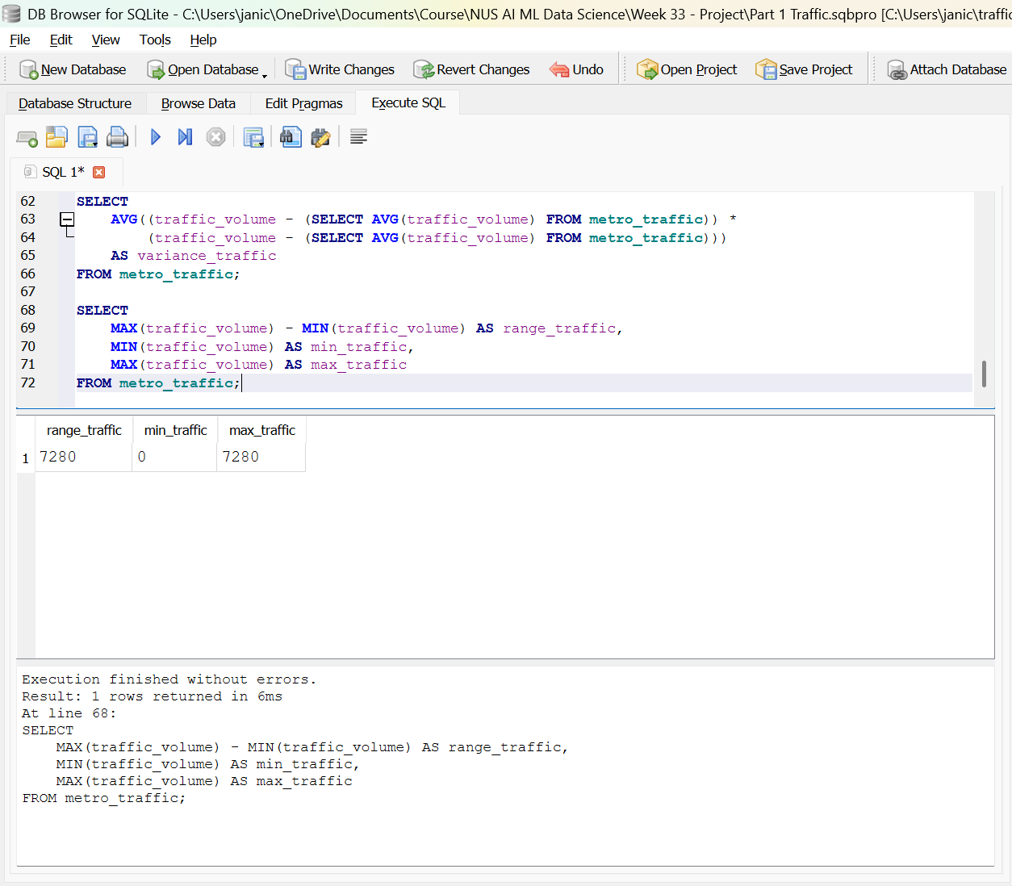

2.2 Correlation analysis
Calculate the correlation coefficient between:
- Temperature
- Traffic volume

Then:
- Interpret the direction of the relationship.
- Interpret the strength of the relationship.
- Explain why correlation does not necessarily imply causation.

Solution:
Correlation = 0.130298798171126

The correlation coefficient between temperature and traffic volume is 0.1303, indicating a very weak positive relationship. This suggests that temperature has only a minor influence on traffic conditions along I-94. While warmer temperatures may slightly increase leisure travel, overall traffic patterns appear to be driven primarily by commuter behavior, time of day, and weekday–weekend cycles rather than weather. Therefore, temperature is not a strong predictor of traffic volume in this dataset.

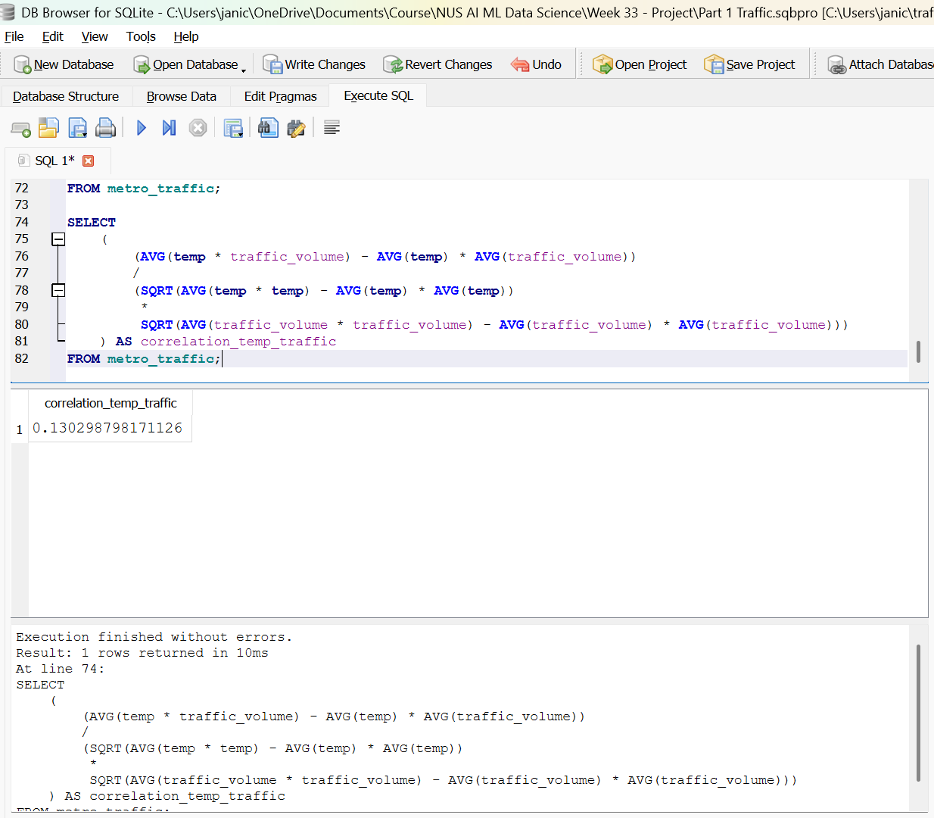

Task 3: Probability and Congestion Analysis
Define congestion as: traffic volume > 5,500 vehicles.
Calculate:
3.1 Basic probability
- P(Congestion)
- P(Clear Weather)
- P(Congestion AND Clear Weather)

Solution:
- P (Congestion) = 0.147290681271264
- P (Clear Weather) = 0.277798522944154
- P (Congestion AND Clear Weather) = 0.0365737283213011

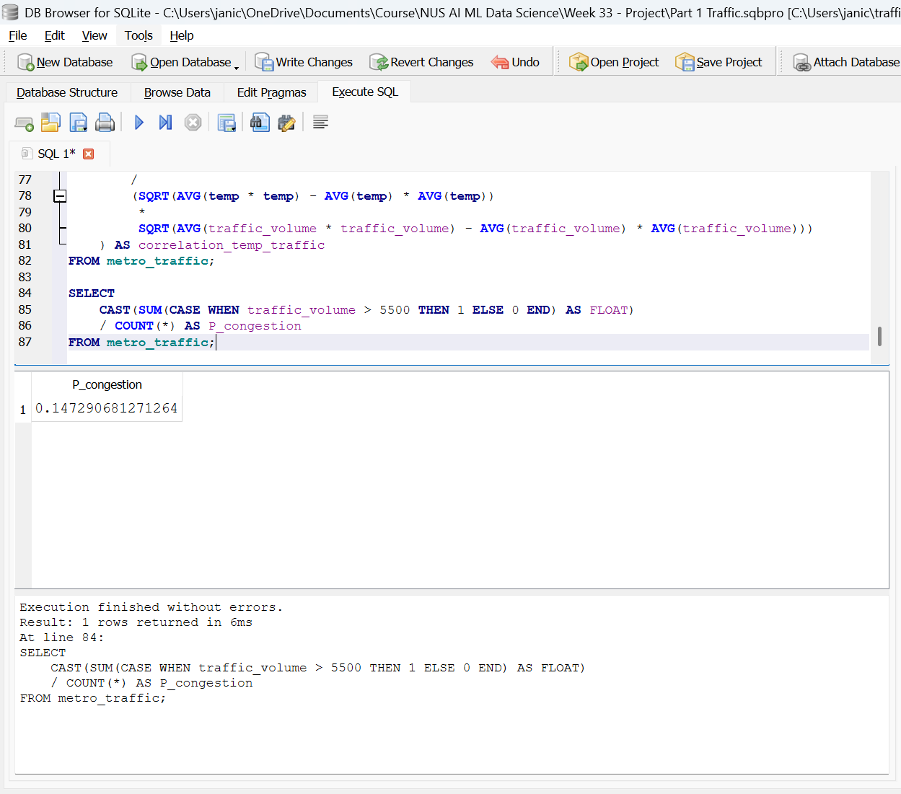

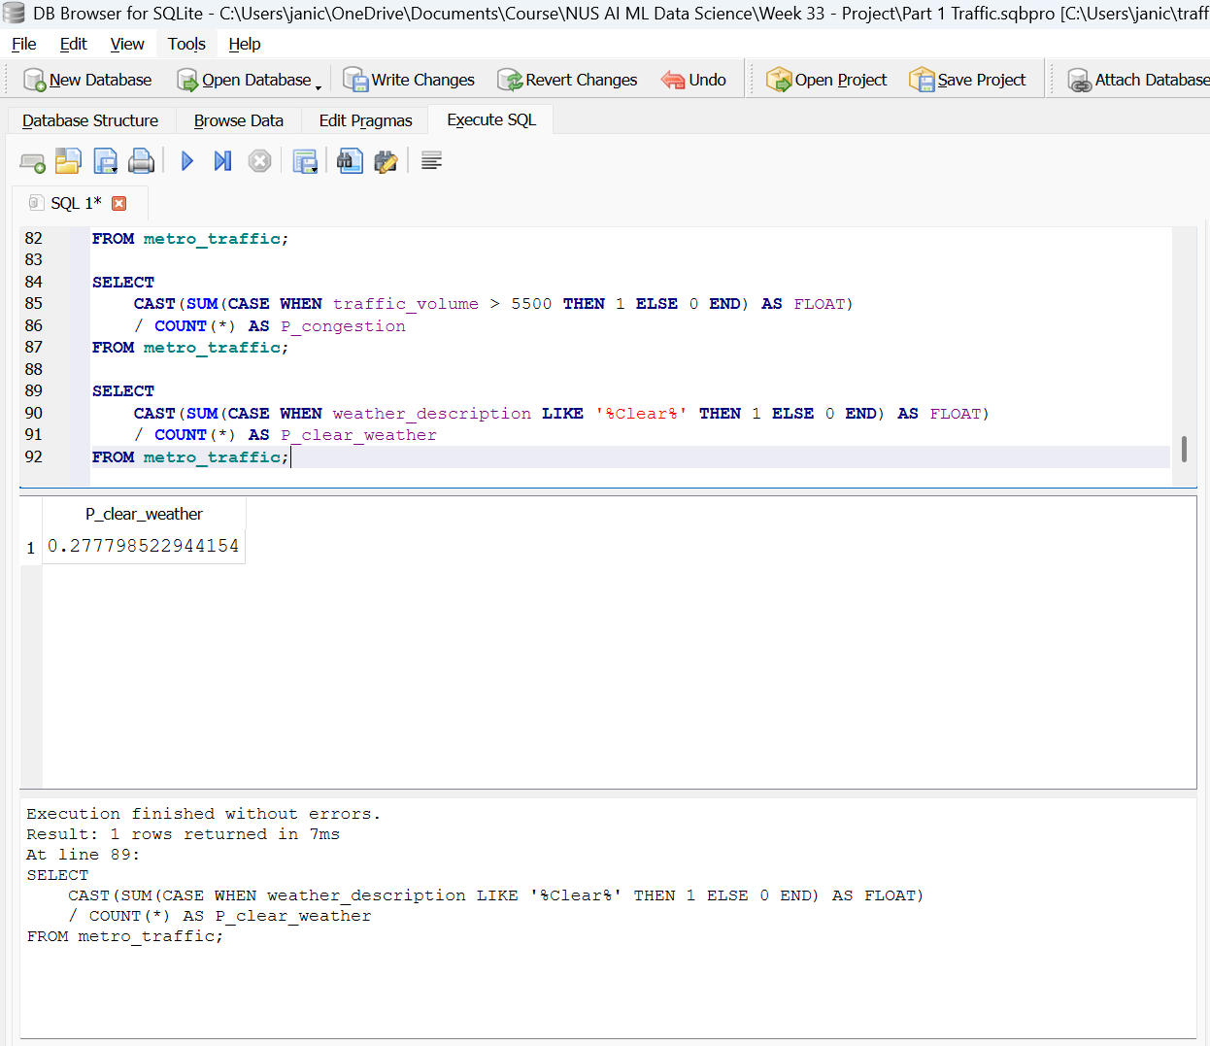

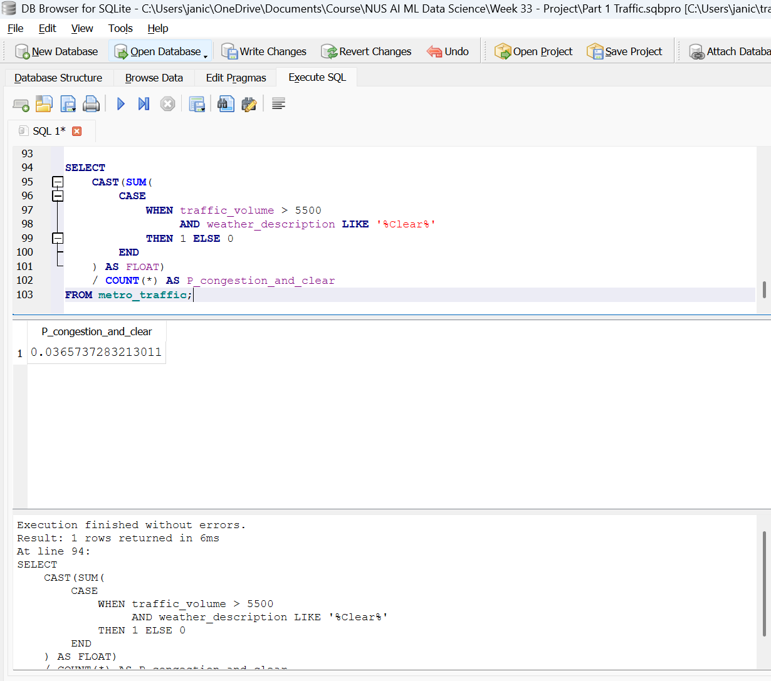

3.2 Conditional probability
Calculate:
- P(Clear Weather | Congestion)
- P(High Temperature | Congestion), where high temperature > 292K
- Determine whether weather conditions and congestion can be considered independent using P(A ∩ B) = P(A) × P(B)
- Calculate the odds ratio of congestion in clear versus cloudy weather.
Conclude with a short explanation of what the probability analysis suggests about the relationship between weather and congestion.

Solution:
- P(Clear Weather | Congestion) = 0.24830985915493
- P(High Temperature | Congestion), where high temperature > 292K = 0.262957746478873
- P(Clear Weather | Congestion) = 0.2483
About 25% of congested periods occur during clear weather. This means congestion is not strongly tied to clear conditions—most congestion happens under other weather types (cloudy, rain, etc.), or simply regardless of weather.

P(High Temperature | Congestion) = 0.2630
About 26% of congested periods occur when temperature is above 292K. Again, this is not dominant—congestion happens both in cooler and warmer conditions, suggesting that time of day and commuting patterns matter more than temperature.
These two values already hint that weather is not the main driver of congestion.

Since P (Congestion) = 0.147290681271264, P (Clear Weather) = 0.277798522944154, and P (Congestion AND Clear Weather) = 0.0365737283213011, then
P(Cong AND Clear) = 0.147290681271264×0.277798522944154 = 0.04094 (rounded) ≠ P(Cong)×P(Clear)
This means that congestion and clear weather are NOT independent.

- The odds ratio of congestion in clear versus cloudy weather = 0.17093115273015
Since Odds Ratio > 1 → congestion more likely in clear weather.
The probability analysis suggests that weather has only a minor influence on congestion along I-94. Although congestion occurs under all weather conditions, the conditional probabilities show that only about one quarter of congested periods happen during clear weather or high temperatures. The independence test confirms that congestion and clear weather are not fully independent, but the difference is small. The odds ratio further indicates that congestion is slightly more likely under cloudy conditions than clear ones. Overall, congestion appears to be driven primarily by commuter patterns and time-of-day effects, with weather playing a secondary and relatively weak role.

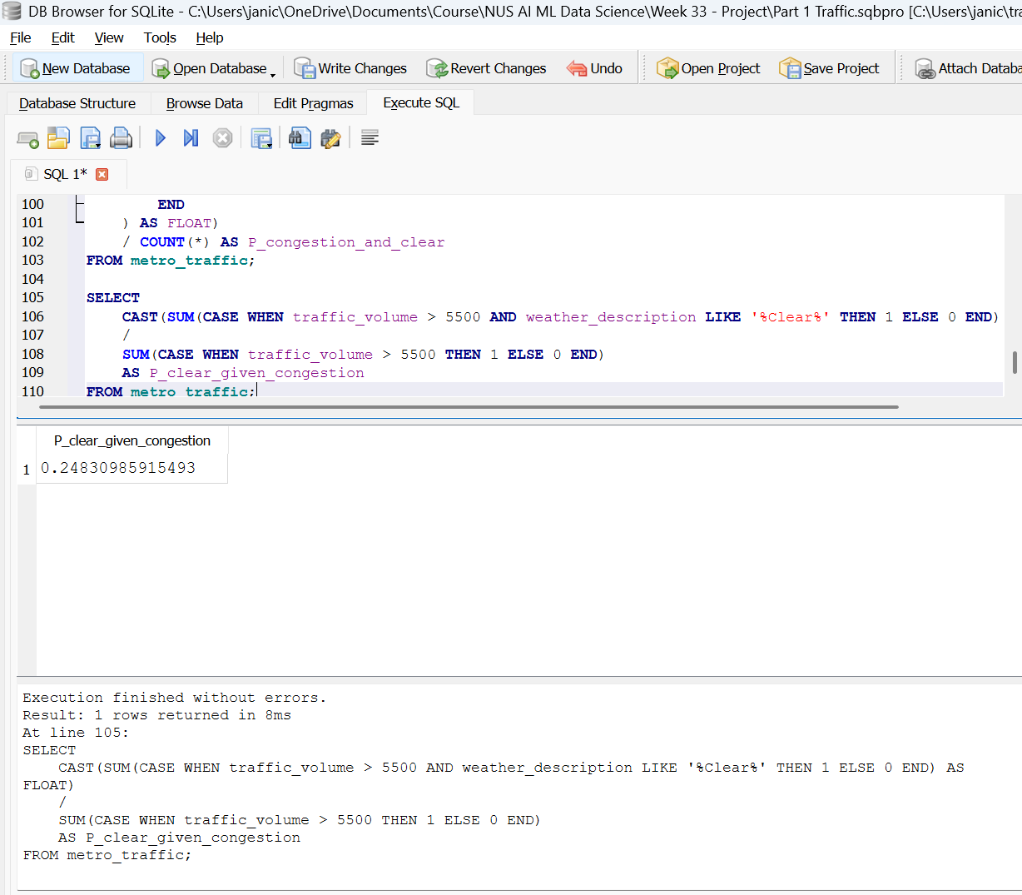

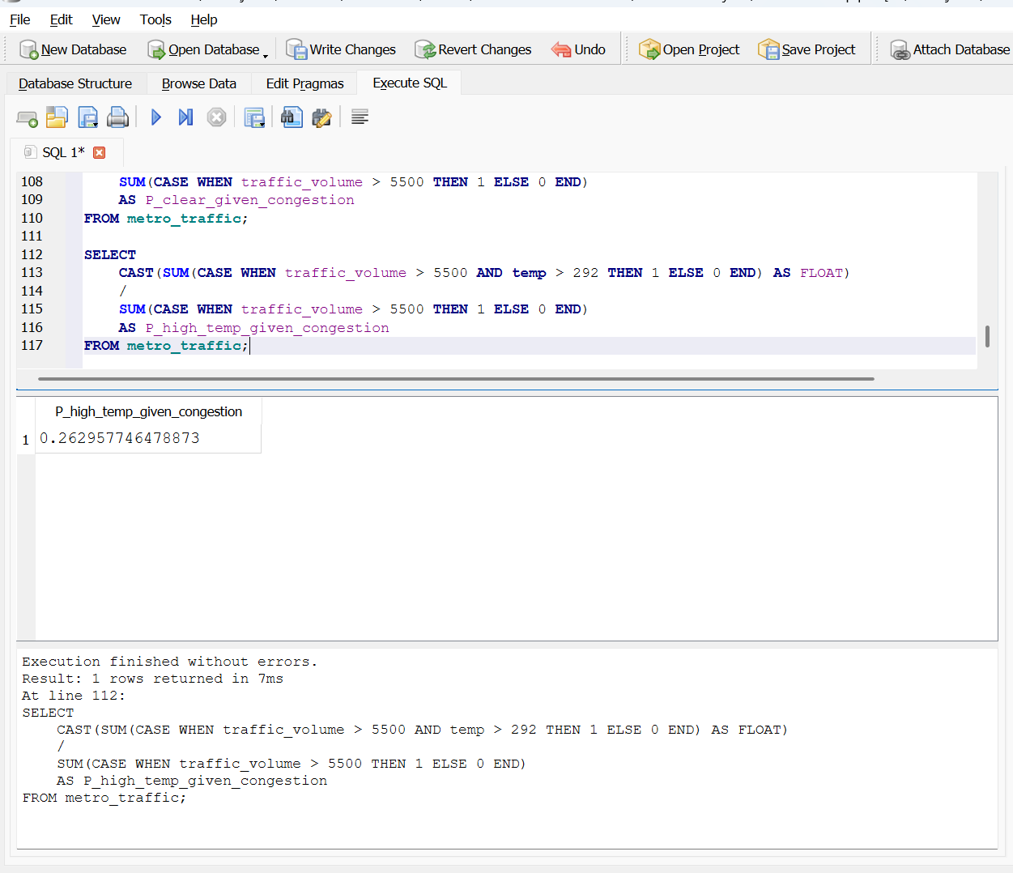

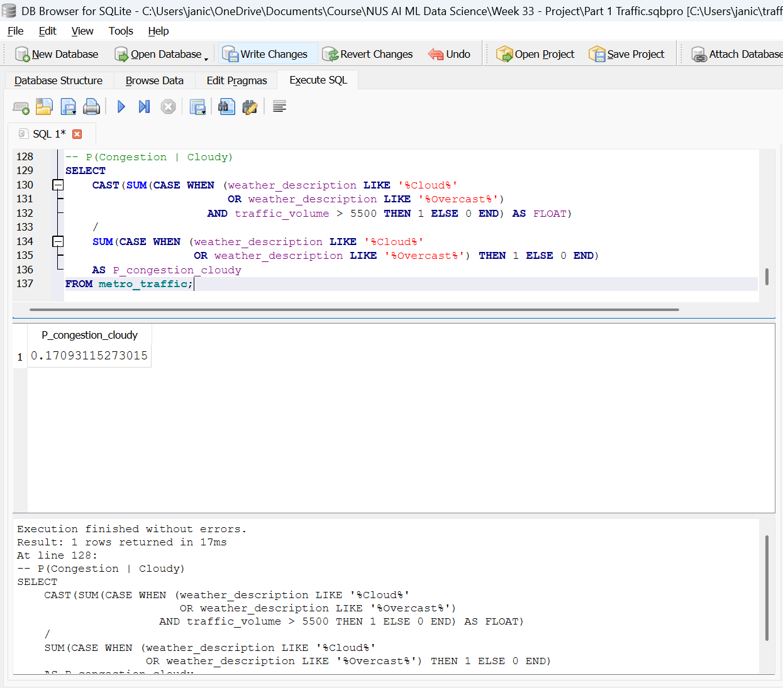

Task 4: Power BI Traffic Intelligence Dashboard
Import the traffic CSV file into Power BI Desktop and use Power Query Editor to prepare the data.
4.1 Data quality and preparation
Perform the following:
- Determine the number of rows and columns.
- Identify null/missing values and the columns affected.
- Check whether the data types are appropriate.
- Extract Hour from DateTime.
- Create Temperature in Celsius.
- Create a Traffic Category:

Solutions:
- 9 columns, 999+ rows
- Missing: holiday / rain_h / snow_h / clouds_all
- All columns were checked for appropriate data types. DateTime fields were converted to Date/Time, numeric fields to Whole Number or Decimal Number, and categorical fields to Text.
- An Hour column was extracted from the DateTime field to support hourly traffic pattern analysis.
- A new Temperature (°C) column was created by converting Kelvin values using the formula °C = K − 273.15.
- A Traffic Category column was created to classify each hour into Low (<4500), Medium (4500–5500), or High (>5500) congestion levels.

The traffic dataset was imported into Power BI Desktop and prepared using Power Query Editor. The dataset contains X rows and Y columns. Column profiling revealed missing values primarily in weather-related fields such as holiday / rain_h / snow_h / clouds_all. All data types were validated and corrected where necessary, ensuring DateTime, numeric, and text fields were properly assigned.
Additional transformations were performed to support analysis. An Hour column was extracted from the DateTime field to enable hourly traffic pattern exploration. Temperature values originally recorded in Kelvin were converted to Celsius using the formula °C = K − 273.15. A Traffic Category field was created to classify traffic volume into Low (<4500), Medium (4500–5500), and High (>5500) congestion levels. These transformations improved data quality and enabled more meaningful analysis in the Power BI dashboard.

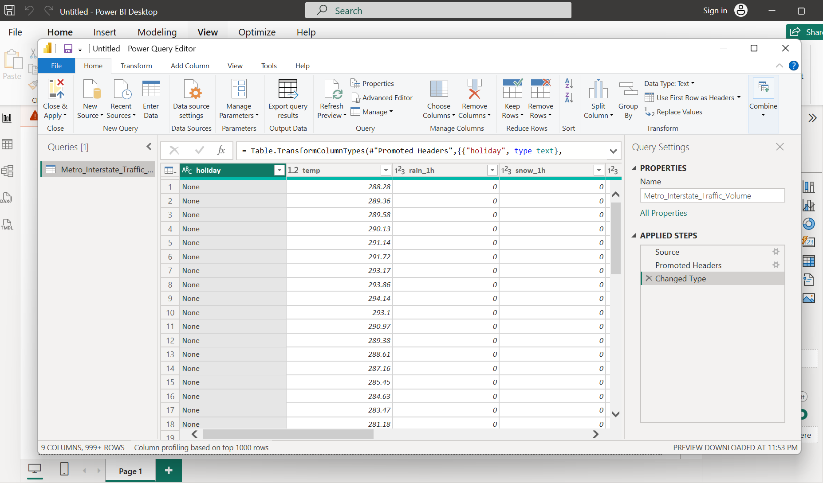

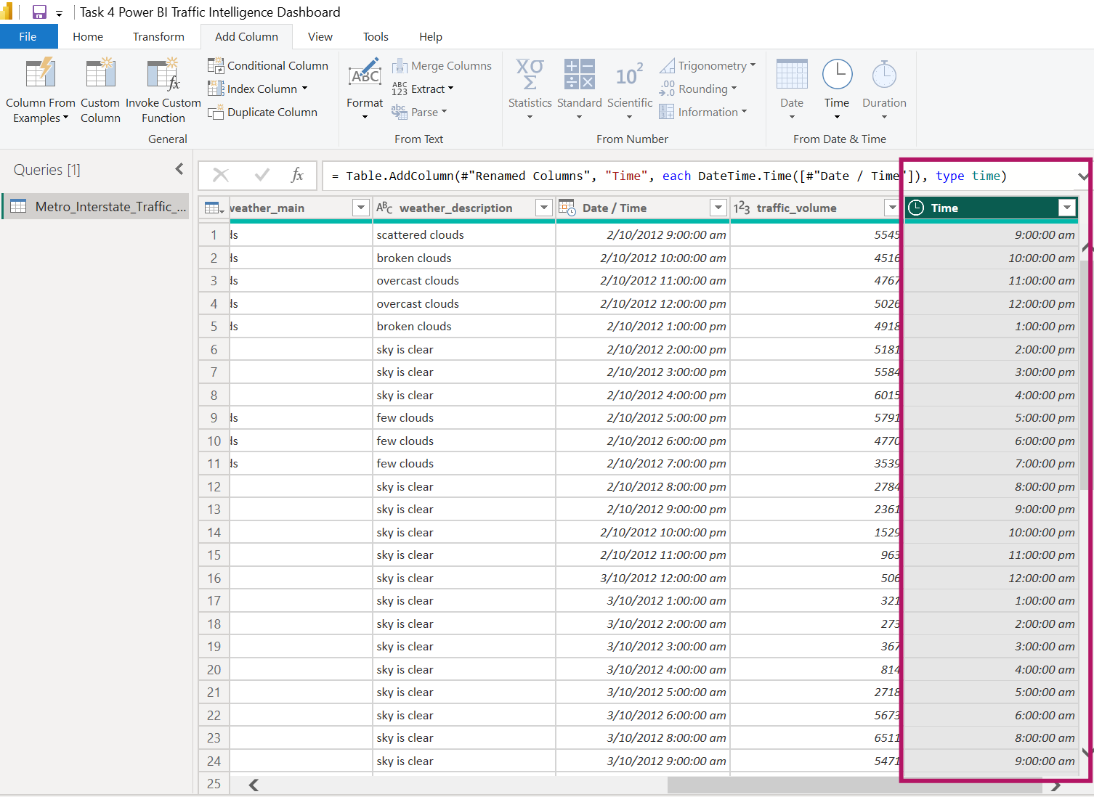

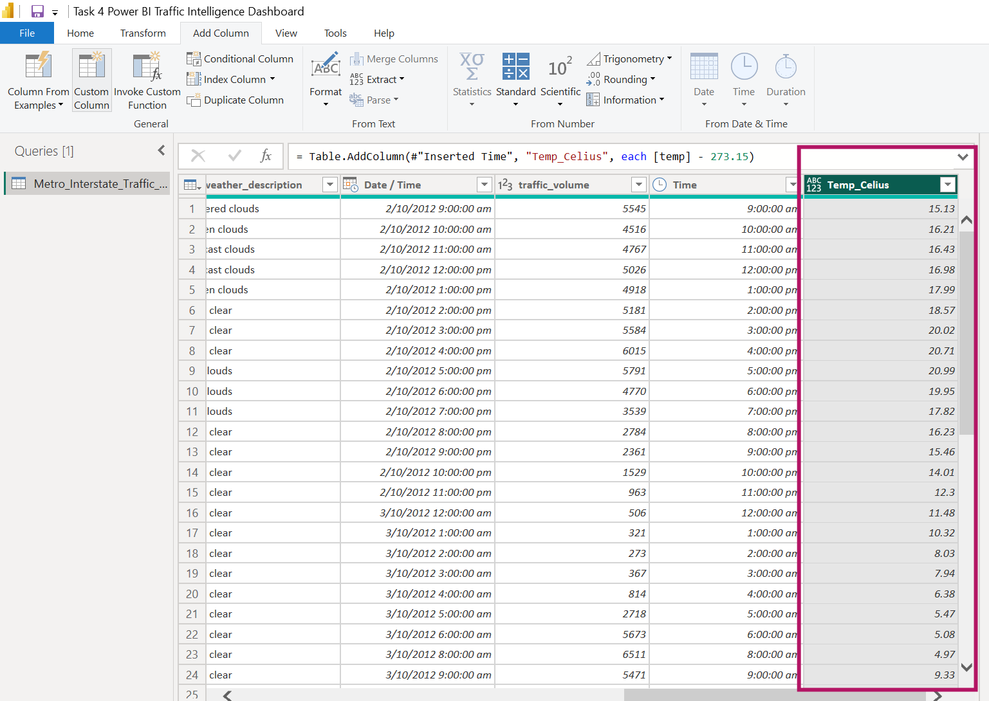

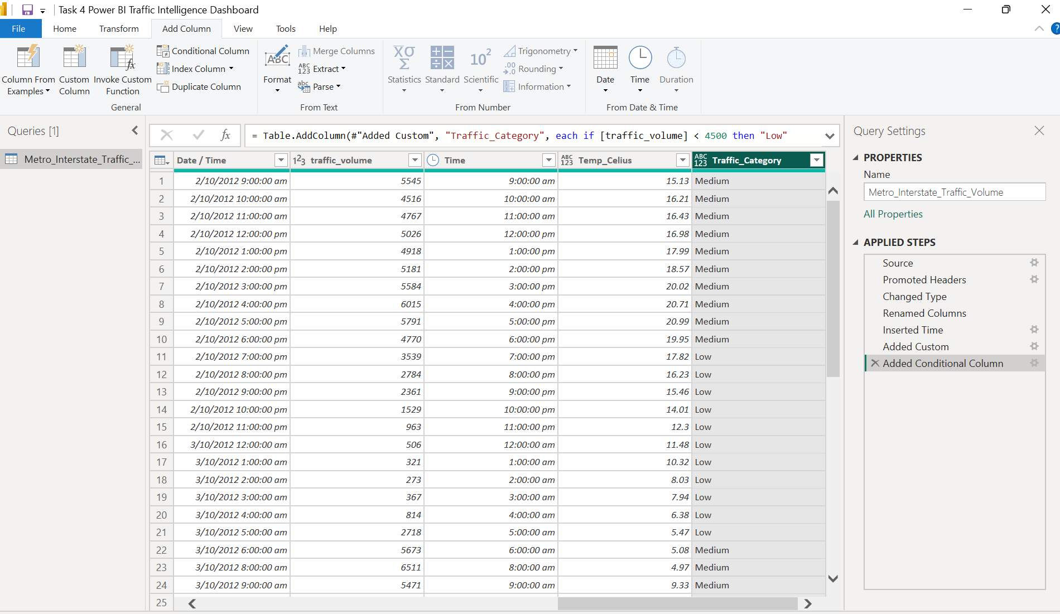

4.2 Dashboard analysis
Create visualisations showing:
A. Daily traffic trends
- Show daily average traffic trends for 2015, 2016 and 2017.

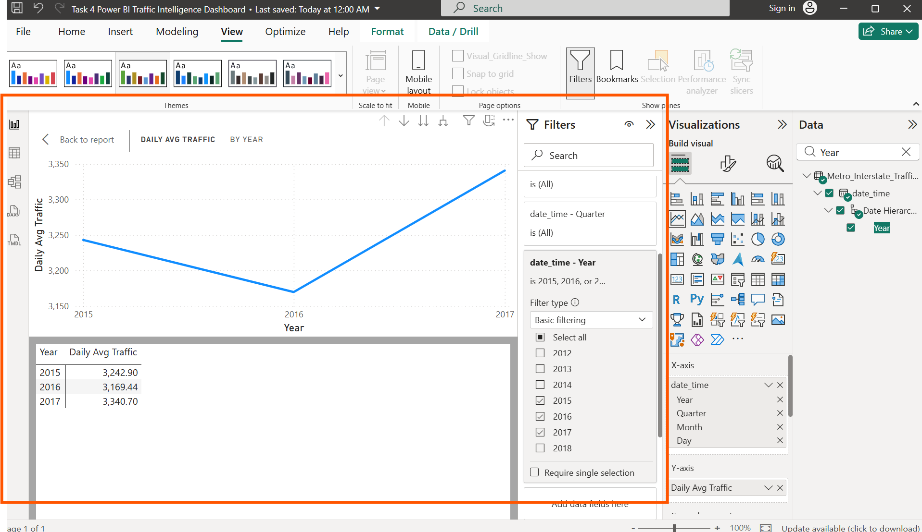

B. Hourly traffic patterns
- Create a column chart showing average traffic by hour for 2017.
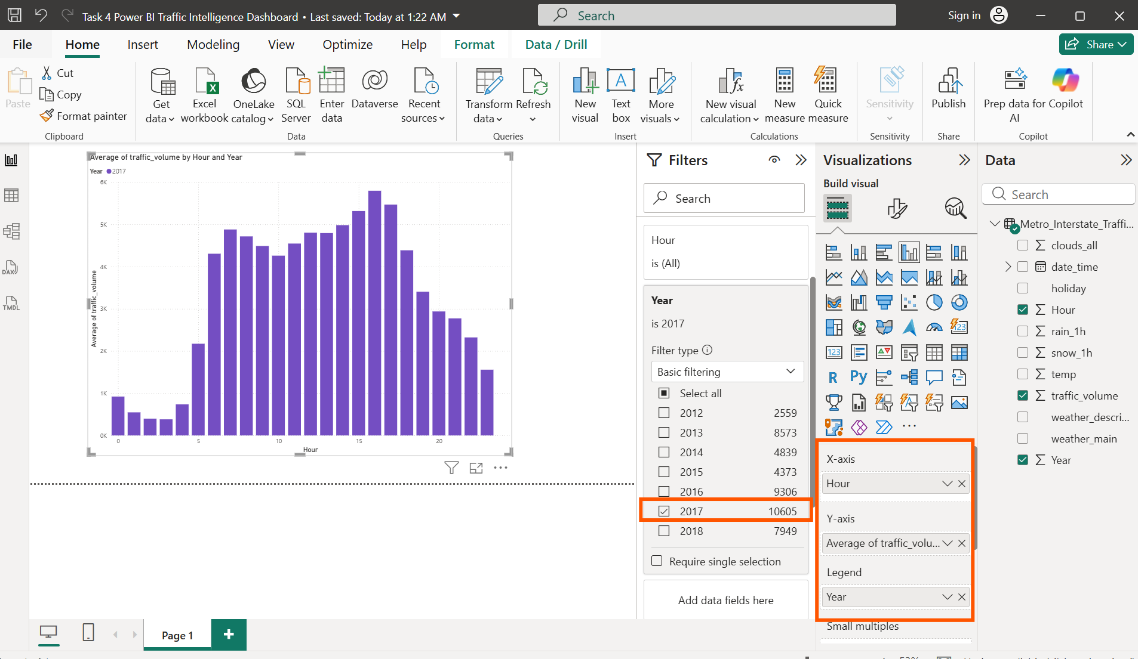

C. Weather impact
Analyse average traffic by weather condition and answer:
- Which weather condition has the highest average traffic?
Answer: Shower Snow

- Which has the lowest?
Answer: Squalls

- What is the difference between the highest and lowest average traffic?
Answer: 5664 – 2061.75 = 3602.25

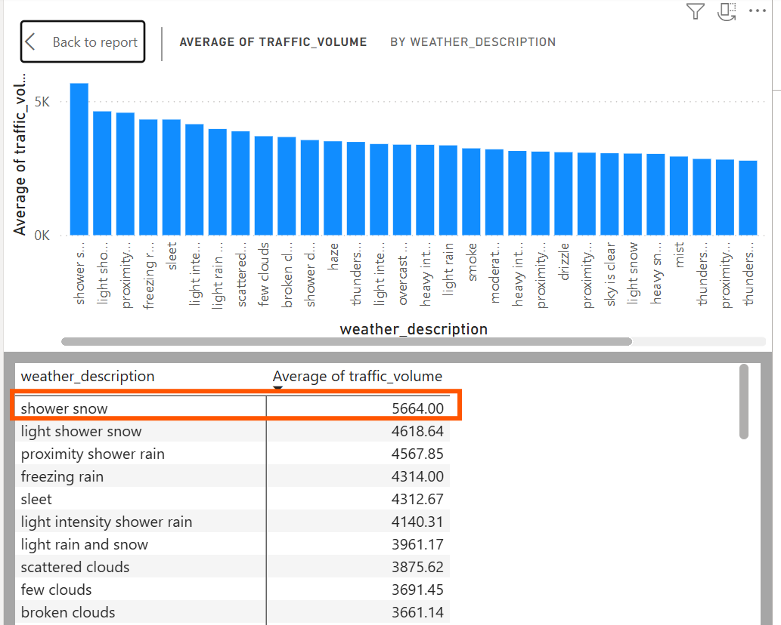
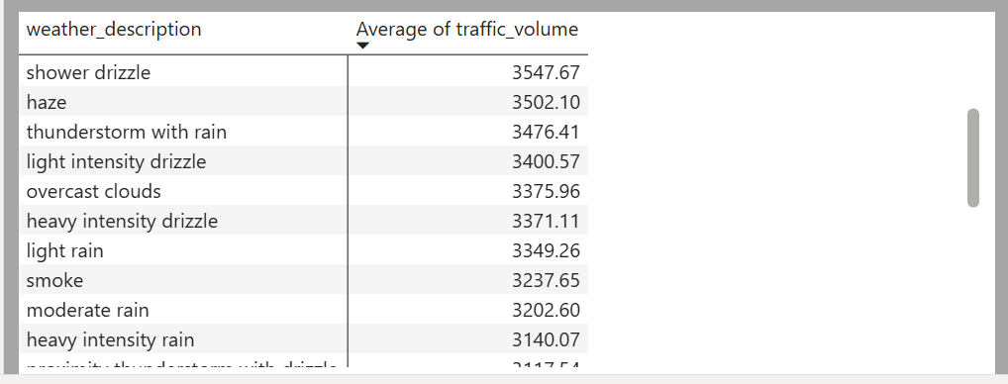
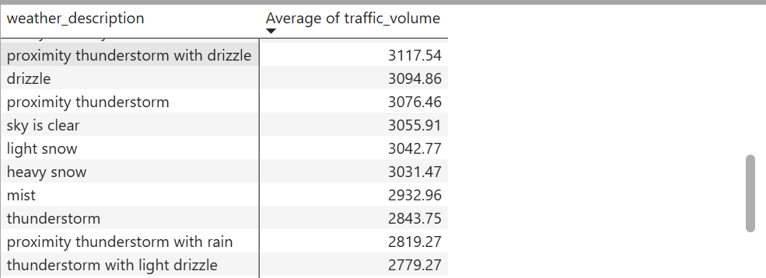
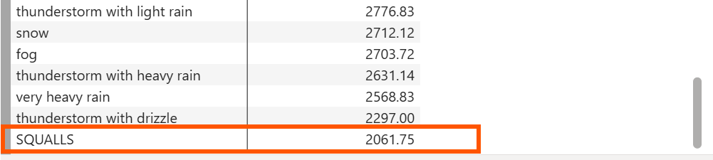

D. Temperature and traffic
Create a scatter plot of:
- Temperature vs. traffic volume.

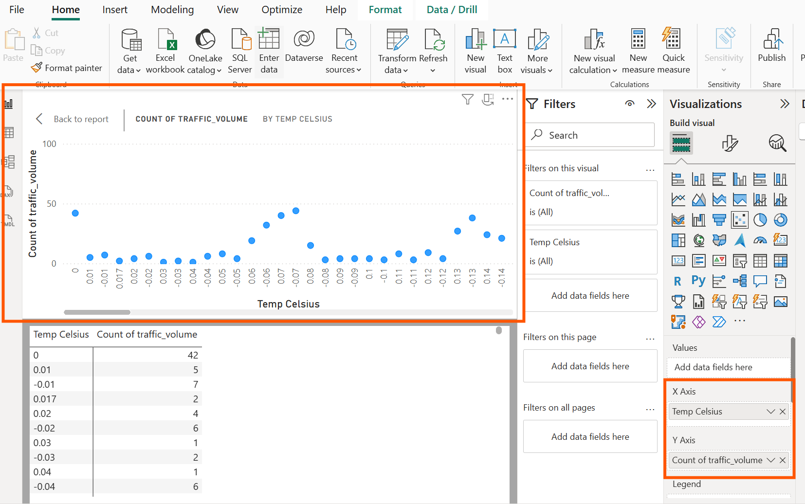

Discuss:
- Whether a visible relationship exists.
- The temperature range associated with higher traffic.
- Any notable outliers.

- There is no strong visible relationship between temperature and traffic volume. Traffic volume does not consistently increase or decrease as temperature changes.
This is expected for the I-94 dataset because:
Traffic is driven mainly by commuter patterns (rush hours)
Temperature varies independently of those patterns
Weather affects comfort, but not whether people need to drive
So the scatter plot shows weak or no correlation.

- Higher traffic tends to cluster around 5°C to 20°C
- These are mild temperatures
- They correspond to typical daytime hours
- Commuter traffic is highest during these periods
- Extreme cold or heat is less common in this dataset

I also notice:
- Very low temperatures (below 0°C) have fewer points
- Mid-range temperatures have denser clusters of high traffic values
This suggests that moderate temperatures coincide with busier periods, but not because temperature causes traffic — it’s simply when most people are out.

- Outliers at very low temperatures
Points around 0°C or slightly below with unexpectedly high traffic counts. These are likely:
- Peak commuter hours
- Winter days with normal traffic despite cold weather

Outliers at high temperatures
Occasional points above 25°C with lower traffic volume, likely:
- Late-night or early-morning hours
- Less common warm periods in the dataset

Outliers with extremely high traffic
A few points sit far above the main cloud — these represent:
- Major congestion events
- Rush-hour spikes
- Possibly holiday traffic
These outliers confirm that traffic spikes are time-driven, not temperature-driven.

Summary
The scatter plot of temperature versus traffic volume shows no strong visible relationship between the two variables. Traffic volume does not consistently increase or decrease with temperature, indicating that temperature is not a major driver of traffic patterns. Higher traffic volumes tend to occur within the moderate temperature range of approximately 5°C to 20°C, which aligns with typical daytime and commuter periods rather than weather effects. Several outliers are present, including unusually high traffic at very low temperatures and occasional spikes at higher temperatures. These outliers reflect specific congestion events rather than temperature influence. Overall, the scatter plot suggests that traffic volume is largely independent of temperature and is primarily driven by daily commuting behaviour.

4.3 KPI cards and filters
Create KPI cards showing:
- Total hours analysed
- Average traffic volume
- Average temperature

Add slicers for:
- Hour range
- Weather condition
- Traffic category

Answers
- Total hours analysed = 48,204
- Average traffic volume = 3.26K
- Average temperature = 281.21 Celsius

